WEEK 4.1

Day – 1:
The Scenario: The team wants to add a comments section under each task on the board. Requirements: any logged-in user can add a comment to a task. A user can edit or delete only their own comments. Each comment shows the author's name and how long ago it was posted (like "2 hours ago"). Comments appear oldest first.
Question and answer:
1. What components do you need? Draw a simple box diagram (on paper or in a text file) showing each component and what it contains.
Ans: Folder structure:
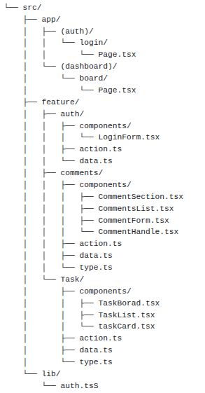
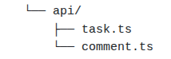
Components list and what it contains:
- login / page.tsx : contain the design layout of Login page and the <Login forms> component page is imported.
- board/page.tsx: contain the design layout of dashboard page. contain tasks & comment section component.
- auth/components/Loginform: contain form structure & manage States for each field (email, password...)
- auth/action.ts :-user logged in logic, manage & checks the data with database. login, logout, register manages & manage email, password matches logic.
- auth/ types.ts: structure of interface/type of login schema and validation of login form (zod, Yup, By-hand)
⇒ comments / components:-
- comment/CommentSection.tsx:- main comment component contain all components of comment section. fetch the data of comment list.
- comment/CommentList:- list of comments with sorting oldest to newest.
- comment/CommentForm:- it contain the form for posting the comment. contain comment input field & Post button.
- comment/CommentHandle.tsx: it contain the logic of that current user & commented user id is matches then it shows the edit & delete button under the comment list of each comment.

- action.ts: contain & manage the logic of create, edit, delete comments. It contain the logic of author id and current user id matches or not.
- data.ts:- to store mock data or a fake data.
- type.ts:- datatype / interface for comment & validation.
- Lib/ auth.ts:- session verify logic. if current user exists or not.
=> task/ components:-
- task/ components/TaskBorad.tsk:- Displays the task board and provides the task data of all tasks.
- task/components/TaskList.tsx:- Display the list of all the tasks
- task/components/TaskCard.tsx:- Display one task and its comments
2. For each component: does it need its own state, or does it get everything from a parent?
Ans:

Component | Own State? | Reason
TaskBoard | No | It have the components related to task (TaskBoard, TaskList)
TaskList | Yes | Receives tasks from api/task.ts and displat the all data
TaskCard | No | Receives a task from api/task.ts and in one card contain the details of each task
CommentSection | No | It contains all the components of comments
CommentForm | Yes | Needs states from manage and store the comments and display them also for error, loading
CommentList | Yes | Gets comments and displays them and managing the order of the comments(oldest to latest)
CommentHandle | Yes | It checks the loggedin user and commented user id is same then show the delete and edit button so for managing the error and delete, it need the state

3. Which parts are Server Components, and which must be Client Components? Why, specifically, for each one?
Ans:
- login/page.tsx (Server Component):- contain the login page layout and renders the login form. It doesn't need browser-side state and useStates.
- board/page.tsx (Server Component):- contain the dashboard layout and import other component of task and comment.
- auth/components/LoginForm.tsx (Client Component):- contain the login form, so require uesState for manage email, password stc..
- comment/components/CommentList.tsx (Client Component):- it only receives comments and displays them in oldest-to-newest order, it doesn't need state.
- comment/components/CommentForm.tsx (Client Component):- User types a comment and clicks Post, so it needs browser interaction and form state.so it contain the states and manage submit form.
- comment/components/CommentHandle.tsx (Client Component):- it manage edit and delete functionality so it needs the state and on browser it happen.
- task/components/TaskBoard.tsx (Server Component):- Displays the task board and all small component of tasks.
- task/components/TaskList.tsx (Client Component):- Displays the list of tasks and state require for arranging them in sort.
- task/components/TaskCard.tsx (Server Component):- Displays one task and its comments no state require for this.
4. Where does the data come from, and which component is responsible for fetching it?
Ans:
- The data is come/fetch from the api.
- The api/task.ts is responsible for fetching the task and passing it to TaskList and TaskCard.
- The api/comment.ts is responsible for fetching the comments for selected task.
- CommentList receive the comments and displays them in oldest-to-newest order.
- Creating, editing, and deleting comments are handled by functions in comment/action.ts
5. What would you name each file and folder? Why that structure?
Ans:
- login/ and board/ contain the pages and routes.
- auth/ contains everything related to login, like login form, authentication actions, and types.
- comment/ contains all comment-related components and logic. It contain comments together and its feature to manage them easily. ronments, running it directly in the browser often requires polyfills or hacked
- task/ contains the components related to displaying and managing tasks.
- components/ folders contain UI components for each feature.
- action.ts contains actions such as creating, editing, deleting comments, or handling authentication.
- data.ts contains functions responsible for fetching data from the database.
- type.ts contains TypeScript types and interfaces.
- lib/auth.ts contains shared authentication and session logic that can be used by different parts.
- This structure divides each function and functionality in separate folder.So it is easy to get that all the related files for each functionality kept in a same folder and can access form the same.

Task Deatils:

Comments:
Write comments here...
Comments list:
Om Patel 2 hours ago
Edit Delete

Day – 2:
The Scenario: The team needs a "Create Task" form with these fields: Title (required, 1-100 characters), Due Date (optional, but if given, must be today or a future date), Priority (required, one of Low / Medium / High), Description (optional, up to 1000 characters). The form must work well on mobile.

Question and answer:
1.List every way a user could submit bad data to this form.
Ans:
title:
- empty title
- unnecessary space before & ending of title
- title longer than 100 characters
Due dates.
- try to enter old date
- incorrect format of date
- invalid date. (months >12, date >31)
Priority:
- Priority is not selected
Description:
- empty description
- description contain more than 1000 characters

2. Look at 2 validation libraries (Zod and Yup are good ones to compare) - what do they actually give you that hand-written validation doesn't?
Ans:
Requirement of validation library:
- It reduce writing multiple if else validation by hand
- Reduce code length
- Reduce code duplication
- writing validation by hand forces to create Typescript Interface/type for validation functions.
- But library have different object to handle error, validation & set the min, max, string, number, email.
- So we can easily use and integrate them to create validation instead of using by hand validation.
- changing the is validation easy. e.g change length 3 to 6 is easy with .min(6) in library but in By hand, we have to change the whole logic, validation, regex algorithm.
3. For this specific form, would you use a library, or write the checks by hand? Write down your reason, not just your choice.
Ans:
- For this specific form. There are only 4 fields.
- So we can use and it it is easy to use by hand code validation.
- But if we are not using the library then the will become long, messy and may be it contain multiple if/else Statement
- Which may be cause difficulty when we will edit the field or add new fields in the future
- so it is good to use Library for Validation Library one this.
Zod: if working on a typescript project & prioritize safety and code , zod is the excellent choice for this. Easy integrate with typescript, developer friendly API and lightweight make it powerful tool.

Yup: if need library with a wider range of built in validation methods, a larger community, Greater flexibility so yup is better. Extensive feature make it a reliable choice for the complex scenario.

4. Where should validation happen - only in the browser, only before the API call, or both? Why?
Ans: In this scenario, I use library (Yup/zod) or by hand code for validation, so for this reason validation done on the browser. browser immediately check the form data & if there was an error it shows error. and if backend API has also validation, then it also done & check validation on server side. So, both are for check the validation necessary

5. What should the user see when validation fails? Be specific about each field.
Ans: if validation fails of any field then it must show the clear error or validation related message for fail. Message must be simple and explain the error easily so user simply read and understand what he had done wrong and fill the form according to the requirement.
e.g:
- Title required.
- Title must be less than 100 characters.
- Select valid due date.
- Due date must be valid date.
- Date is invalid.
- Priority must be selected.
- Select the valid priority.
- Select the priority between Low, Medium, High.
- Description must be less than 1000 characters.

- library or by hand, with your reasoning:
Ans: I want to use library for this. Yet these are less field for validation so we can write by hand but if use library for this, then there are many validation method & objects which are easy to implement &it is east if there will some edits or will add more validation and the fields in future. Also it contains less line of codes and ignore multiple if/else statements.

- Yup library validation:
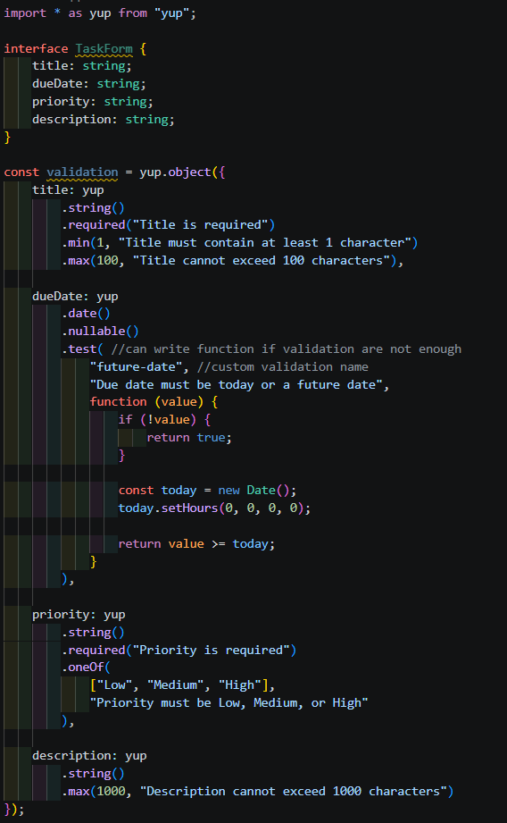
const titleRegex = /^[a-zA-Z0-9\s'-]+$/;
yup.matches(titleRegex, 'Title contains invalid characters');

- By hand validation:
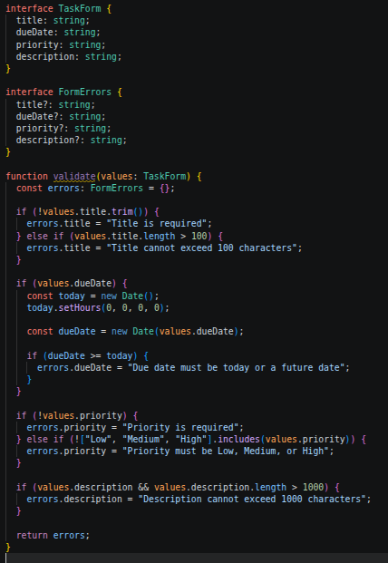

Day – 3
The Scenario: The task board needs: a status filter (To Do / In Progress / Done / all), an assignee filter (a chosen person, or all), and a search box that filters by title as the user types. If the user sets filters, opens a task, and clicks back, the same filters must still be applied - they must not reset.
Question and answers:
1. List every piece of state this feature needs (filters, search text, the task list, the currently selected task, etc).
Ans:
- status filter: (To do, progress, Done)
[statusFilter, setStatusFilter]: for which task status the user has selected & show only matching task.(useSearchParams()).

- Assignee filter:-
[assignee Filter, setAssigneeFilter]: for which person the user want to see tasks for.
- Search Text:-
[searchTask, setSearchTask]: for remember what user type and filter tasks by their searh
- Task list:-
[ tasks, setTasks]: to store the task coming from API & newly added task
- currently selected Task:-
[selectedTask, setSelectedTask]: To store currently selected task id & manage it for showing the task which have same id
- Loading State:-
[ Loading, setLoading]: for managing loading. if task are take time for rendering till that show loading
- Errors:-
[errors, setErrors]: For managing the errors
2. For each piece: local component state, Context, a state library, the URL, or server state (fetched data)? Pick one for each, and say why.
Ans:
- Local component state:-
- Use when only one component needs the information
- information doesn't need to share with unrelated component
- context:-
- allows to share state between multiple components without passing it through props at entry level.
- state library:
- Use when: many different parts of a large application need shared state
- state management becomes complicated
- You have many relationship between pieces of client side state
- URL state (use useSearchParams)
- information stored in browser URL.
- can use the same URL again.
- for fiter, search, sorting, pagination.
- Make a useState for searchParam and then use .get(“status”) method for getting the data of status
- server state:-
  - comes data from an Api/backend.
  - can be changed by server.
  - And if want that data refetch automatically(e.g. social media)
Which is used for which state:
- status filter (URL) :
- this shows the list of task after filter. it must remain applied when the user opens task & click Back, so storing in it URL allows the browser to preserver & restore it.

- Assignee filter (URL):
- it is also used as filter. it survive navigation & filter are not reset.
- Search text (URL):-
- functionality of searching also do filtering of task & it also need to surviving navigation.
- currently selected task (URL):-
- it represent by its ID in the route, (task/15) it tells what id currently open & filter that task.
- Loading/error (local):-
- loading is use as temporary information needed by component while fetching date so locally
- same for error. just showing error.

3. Which pieces of state depend on each other? What happens to your design if two pieces of state can get out of sync?
Ans:
- status filter – independent
- assignee filter – independent
- search filter – independent
- filtered list – status + assignee + search
- task list – API server
- selected task – task list (specific ID)

- what happens if state out of sync:
- when we have 2 to different states like [task, setTask] for all task List & [filterTask, SetFilterTask] for filter, then it can goes out of sync.
- If we update some of the field in Task list,it will not update automatically in filter list. so It get out of sync.
- Instead of making two different State for managing and to prevent out of sync condition, we simply make a filfertask variable and write the logic for filter(.filter()) for derive filter task in it & then simply map the filter data.

4. If the filters must survive a page navigation, where does that push you? Why not just use useState for that?
Ans:
- for this (surviving page navigation) we are using URL. So URL can store the filter option like /tasks?status=InProgress&assignee=Om& Search=research
- if we use useState, It store value in React component. All filters stored in usestate store component's current state. when the page is navigated the component be removed & recreated, & states are reset. Usestate does not automatically become part of browser's Back / forward history.
- URL allows to stores the values of filters stored & remember allows filter to remain during navigation.
- When Next.js loads the page, it extracts query parameters during the initial render loop, it often right on the server and uses them to instantly populate the UI components.
- If the filters must survive page navigation, we should store them in the URL. This allows the selected Status Filter, Assignee Filter, and Search Text to remain available when the user opens a task and comes back. We should not depend only on useState because it is component-level state and does not automatically preserve the filter values in the browser's navigation history

Piece of State | Where should it live? | Why?
Status Filter | URL | The selected status needs to remain available when the user navigates to a task and comes back.
Assignee Filter | URL | The selected assignee should also survive navigation and can be restored from the URL.
Search Text | URL | The search text needs to remain after navigation, so storing it in the URL allows the same search to be restored.
Currently Selected Task | URL / Route | The selected task can be represented by its ID in the URL, such as /tasks/15.
Loading State | Local Component State | Loading is temporary information needed while the component is fetching tasks.
Error State | Local Component State | The error message is temporary UI information needed when fetching the task list fails.

Why don't we use Context here?
We don't need Context or a state library for this feature because the main requirement is that the filters survive navigation. The URL solves this directly without adding unnecessary complexity.

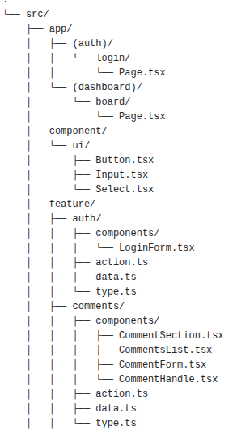
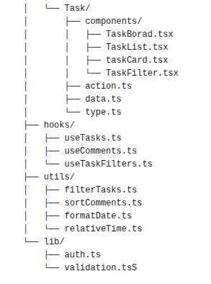
Day 4:
The Scenario:- There is a "Mark as Done" button on each task card. Clicking it calls the API to update the task's status. The API can be slow (a few seconds), can fail outright (network issue or server error), or the task may have already been deleted by someone else in the meantime.
Question and answer:-
1. List every way this can fail: the network is down, the API is slow, the API returns an error, the user double-clicks the button, the user's data is now stale because someone else changed it.
Ans:
- It can fail due to slow network connectivity or network connectivity is not working.
- If user clicked the button mulitple times then it also call the api the api back to back multiple time cause the reason of failure.
- If there is an error occur while the api is called then it also cause the reason of failure. e.g. internal server error (and unhandled error), api is not working
- The api is taking longer time for respond the data to the user.
- If someone delete the task and the the user clicks on the mark as done button then it can be fail because before the task status is changed, someone else delete the task.
- User login session is expired or any unauthnticated user try to call the api then it can be also fail.

2. For each failure, what should the user see? Be specific - not just "show an error", but what the error says and what the user can do next.
Ans:

- slow connection:-
  - mark as done button converts into marking as done.. button with a loading.
  - User can wait until the request is not fulfill.
- No connection:-
  - Show the error message – “Cant perfom the action.your internet connection is not working. Please check the connection and try again”.
  - User will check the internet connection and refresh it and try again.
- Button is clicked multiple time:-
  - shows the message – “you are performing too much action. please wait for response.” or “button clicked multiple time.please wait for response.” for this we can disable the button after the first click by user till the response is not get.
  - User can wait for the first action’s response.
- Api is taking longer time:-
  - It shows the “loading” state or the button is converted into loading and it also show the message like – “The request is taking longer time then expecteed.Please wait for the response..”.
  - User can wait for the response and then click try again if request fail.
  - If api taking too much time time for fetching the details then we can use AbortController() to abort the api action.
  - But the fetching api action is running on the background, so it will manage by the backend.
  - HTTP 504 Gateway Timeout: The maximum time is given to api often 30 or 60 seconds. Then backend sends the 504 error.
  - HTTP 408 Request Timeout: The server closed the connection because the network connection was too slow, or the request body took too long to completely upload.
- someone else delete the task:-
  - it shows the message to user – “This task is not avaible because of the other user deleted the task”
  - user can move further to the task list.
  - Backend sends 404 – NOT FOUND error.
- Session expired / unauthenticated user:-
  - shows the message – “Please login first to perform this action”. After showing the message, the user automatically redirect to the login or register page.
  - User have to login the system and then can perform the action.
- Error in the api:-
  - it shows the error message – “There is internal server error in the api calling. Please try again for performing the action. ”
  - user have to click on the try again and try to perform the action again.

3. Should the button update the screen right away and fix it later if the API call fails (optimistic update), or wait for the API to confirm first? Why, for this specific case?
Ans:
- In this question, there are two condidtion:
  - If user clicks the mark as done button then UI show the Done immediately means on browser it show the Done but api working the background, if api succeed then then everything is fine but if the api failed then we have to change the UI showing the correct message and showing the error after api fails.
  - The other is that, on browser side UI does not show the “Done” for the task untill api is not succeed. When the api sent the request and it succeed then and only then it will show the done message or the error message. Till than we can disable the button and convert it into “Marking as done..” with loading.
- For the task I have to choose that UI wait for the api to confirm the first then show the message.
- Because as we discussed first, there are many reasons who are responsible for failure of api.
- And also if other user perform delete on the task before the api sent a request, the api fails.
- If the ui immediatly show the message and then api fails, it will create inconsistant screen with different message anf will difficult to manage this.
- Instead of this, we can simply wait for the api for success/failure till then we can show “Marking as done..” on the page untill api sent the request.
- After that we can give specific success or failure message to user through the screen.

4.How would you stop a user from double-clicking and sending the same request twice?
Ans:
- If the user is clicking the button multiple times...
- we can use “disabled” method and disable the “Mark as done” button.
- And show “Marking as done..” with loading instead of “Mark as done.”
- So after the click, the button will be disabled so user cant perform the action or cant click the button multiple times.
- After the action is performed and completed it will show “Task is marked done”.
- Or it fails then it shows “Try Again”.
- So that user can perform the new action.
Failure case | What the user sees | What the code does
No network connection | “Cant perfom the action. your internet connection is not working. Please check the connection and try again.” | User will check the internet connection and refresh it and try again.
Network is slow | mark as done button converts into marking as done.. button with a loading | User can wait until the request is not fulfill.
Button is clicked multiple time | “you are performing too much action. please wait for response”, Button changes to “Marking as Done…” and becomes disabled | User can wait for the first action’s response..
Api is taking longer time | “The request is taking longer time then expecteed.Please wait for the response..” | User can wait for the response and then click try again if request fail.
someone else delete the task | “This task is not avaible because of the other user deleted the task” | user can move further to the task list.
Session expired / unauthenticated user | “Please login first to perform this action”. After showing the message, the user automatically redirect to the login or register page. | User have to login the system and then can perform the action.
Error in the api | “There is internal server error in the api calling. Please try again for performing the action. ” | user have to click on the try again and try to perform “mark as done” action.

Day – 5
The scenario: The product team wants a user profile page: an avatar (users can upload/change it), a display name (editable), a bio (editable, up to 300 characters), and a list of the user's last 20 actions on the platform (for example "created task X", "commented on task Y"), most recent first. A backend team will build whatever API this page needs - you do not build it, but you specify exactly what you need from it.

Question and answer:
1. Component breakdown (like Day 1):
Ans:
Components List:
- UserProfile.tsx:– main profile component that contain the user information, edit form, action list.
- EditForm.tsx:– contain the edit form for changing the user’s detail (name, avtar, bio)
- UserInfo.tsx:– dispaly the user information. Name, bio , avtar.
- Avtar.tsx:– contain the users avtar and the option to chenge and upload.
- UserAction.tsx:– List of user action (last 20 actions).
- ActionItem.tsx:– contain one single action from the list with the time.
Does it needs own state or depend on the parent:
- UserProfile.tsx:– No state require. Contain the all the component which are connect to user profile.
- EditForm.tsx – needs local use state to manage for the current value and edit value and also need states for if is it in edit state or not so that it can render the edit form to user.
- Avatar.tsx:- State require to manage upload and change.
- UserInfo.tsx:- No state require. It shows the data of the user and display them.
- UserAction.tsx:- No state require. It fetch the user action.
- ActionItem.tsx:-No state required. It fetch the one single action and display it.
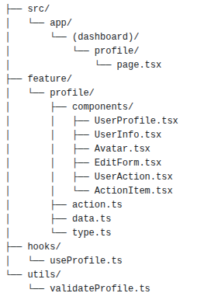
Folder Structure:
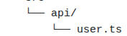
- The profile feature has its own components, data fetching, server actions and types.
- So every thing related to usree profile is in the: feature/profile.
Server / Client component:
- UserProfile.tsx (server component):– Main component that conatin all the component. No state required so by default server component.
- UserInfo.tsx (server component):– Display the data of user from the api.
- EditForm.tsx (Client component):- required the fileds and state for manage them for name, bio, avtar.
- Avatar.tsx (Client component):- states required for the change and upload new avtar.
- UserAction.tsx (Client component):- It import the all the actions from the api/ and show the list .
- ActionItem.tsx (server component):- it contain individual action and does not require states.
2. State plan (like Day 3):-
Ans:
List of each state:
- display name [name, setName]:- For manage the name of the user. Show the current user name and if edit the name then show the edited name of the user.
- Bio [bio, setBio]:- For manage the bio of the user.
- Avtar [avtar, setAvtar]:- For edit the currently selected selected new avtar.
- For editing [isEditing, setIsEditing]:- If user is in edit state or not.if it click the edit button then render the edit form.
- For save the form [isSave, setIsSave]: mUser edit the details then it manage the new edited feild that show on the user profile after click the save button.
- For upload the new avtar [isUploading, setIsUploading]:- it maintain the uploadg process of avtar. It is true while avatar is uploading, otherwise false.
- Error [error, setError]:- Manage the errors.
- Loading [loading, setLoading]:- manage the loading.

Local component state, context, state library, url, server state:
- All the other component which manage name, bio, avtar, edit, error, loading, save, uploading all are the local component. Because they manage the field of the form and edit the form and render new values to the users.

3. Validation plan for anything editable (like Day 2):-
Ans:
Bad data that usre can enter:-
- Name:
  - Empty field, avoid the field, do not enter the name.
  - Invalid character. e.g. (,<,/,@ (prevent it by using regex string [a-zA-Z0-9_-])
  - Length is larger or shorter
- Bio:
  - Bio empty if required.
  - Length of the bio is greater than 300 characters.
- Avtar:
  - selected file is not image.
  - Image size is too large.
  - Unsupported image format.
Library or by hand code:
- There are only 3 field in the edit form so it is easy to use by hand code validation.
- Because there are very less fields and no large code for these validation.
- We can easily manage the code because less field.
- But, if there are chances of increase the form’s field then use one of the library.
- Because it provide easily manage the validation code, give multiple methods for validation that make the code very smooth and easy to understand. And also less line of code.
- We can the validation easily in the library.

What should user sees?
- When the entered data is not as per the validation, then user see the proper validation error message under the specific input box of details.e.g,
- Enter valid name.
- Name must less than 20 characters.
- Name is required.
- Bio must be less than 300 characters.
- Please select the valid format of image.
- This file is invalid.
- Image file is too large.

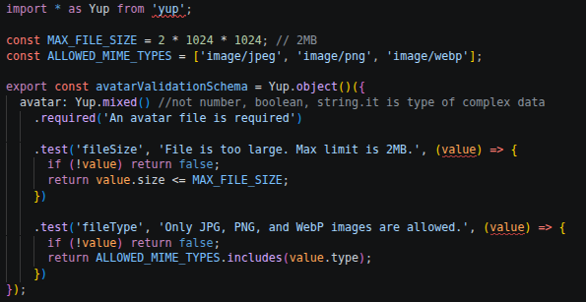
4. Failure/edge case plan (like Day 4)
Ans:
Failure/edge cases:
- It lost the conection due to no network connectivity.
- Slow network connectivity.
- Unauthenticated user edit the usr profile.
- Session expires while user editing.
- User is not logged in.
- Click the save button multiple time.
- Click the upload button multiple time.
- Uploaded image is invalid.
- In user action list, there is no any action performed by user.
- Action data are not loading or loading fails.
- Api data fetching fails.
- Api take longer time than expectd.
What user see:
Edge Case / Failure | What the User Sees | What the User Will Do
No network connectivity | “Unable to connect. Please check your internet connection.” | Check the internet connection and click Try Again.
Slow network connectivity | “The connection is slow. Please wait…” with a loading indicator. | Wait for the request to complete or retry if it takes too long.
Unauthenticated user tries to edit profile | “You must be logged in to edit your profile.” | Go to the Login page and log in.
Session expires while editing | “Your session has expired. Please log in again.” | Log in again and continue editing the profile.
User is not logged in | “Please log in to view or edit your profile.” | Click Login and authenticate.
User clicks Save multiple times | Save button becomes disabled and shows “Saving…” | Wait for the complete the action.
User clicks Upload multiple times | Upload button becomes disabled and shows “Uploading…” | Wait until the upload is completed.
Uploaded image is invalid | “Invalid image. Please upload a valid image file.” | Select a valid image and upload it again.
No actions performed by user | “No actions found.” | No action is required; the user can continue using the profile.
Action data fails to load | “Unable to load your recent actions. Please try again.” | Click Try Again or refresh the page.
API data fetching fails | “Data fetching fails. Please try again later.” | Check the connection and click Try Again.
API takes longer than expected | “This is taking longer time…” with a loading indicator. | Wait for the API response or retry the request.

5. The exact API endpoints you need: method, URL shape, what you send, what you expect back
Ans:
Get User Profile:
- Method: GET
- URL: GET http://localhost:8080/users/my-profile
- What you send: User must have been logged in in the system.
- What you expect back: The specific user’s details: name, bio, avtar.
Edit User Profile:
- Method: PATCH / PUT
- URL: PATCH http://localhost:8080/users/edit-profile
- What you send: The new edited data.
- What you expect back: User’s updated profile with new name, bio, avtar.
- PATCH: it allows for partial updates. if user only wants to change their name, it allows to change.
- PUT: it replacing the entire resource, meaning must always send the name,bio,avtar together.
Upload avtar:
- Method: POST
- URL: POST http://localhost:8080/users/upload-avtar
- What we send: Upload a valid image
- What you expect back: The image which is selected is uploaded as an avtar

Get user’s actions:
- Method: GET
- URL: GET http://localhost:8080/users/actions?limit=20
- What we send: User must be logged in and in user’s profile page.
- What you expect back: User’s last 20 actions on the system.

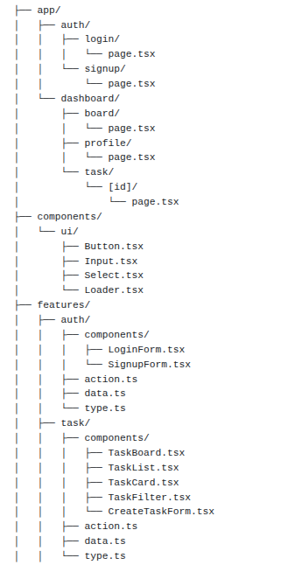
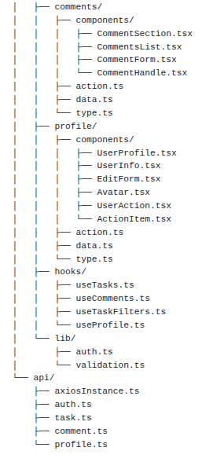
Review:
1. If multiple large amount of requests are there, then what can we do?
Ans:
- we can feth the api in the api/ folder by using axios.
- Install axios and then by axios.create, we can fetch the api.
- By using the axios, we can easily include all the details like baseURL, headers and other configurations.
- after this simply in all other files, just apply the endpoints no need to include the token and headers. (api.get(), api.post())
- we include it with interceptor also, then we can easily pass the header or bearer token to the other different multiple end points.
- Why Interceptor:
- Centralized request handling: With the interceptor, it provides developers to define global request handlers that intercept outgoing HTTP requests. This helps when adding headers, logging, handling errors across multiple requests.
- Global error handling: By defining response interceptors we can intercept error responses from the server and implement the error logic to show the error to user.
- Request transformation: enables developers to modify the request before they are sent to the server, allow to perform action like adding authentication tokens, transforming request data.
- Response transformation: modify response data or configure before the passing to the browser. This used for tasks like parsing response data, handling specification response condition.
- Authorization handle: used for managing authorization logic. By intercepting outgoing requests, developer can check for authorization token or credentials and add them into headers, ensuring authorization request sent to the user.

2. How we can check if author and current is same or not?
Ans: we can match the fields like email or username to validate the user is same or not.
- In backend we can set a flag variable for checking that the user is same or not and it return the flag.
- const canEdit = loggedInUser.id === comment.createdBy;
{
"commentId": "c101",
"text": "Task completed",
"author": {
"name": "Om Patel"
},
"canEdit": true
}
- This flag can be used in frontend to show on the ui. By using,
{comment.canEdit && (
<button onClick={handleEdit}>
Edit
</button>
)}
- Instead of using unique id of user, we can also provide public id to each user from backend.
- So we can user public id for comparing the user like,
- const canEdit = currentUser.publicId === comment.author.publicId
- if both id match then we can show the edit button to the user.
- {canEdit && <button>Edit</button>}

3. Why page.tsx server component?
Ans:
- When a user requests login page, they immediately receive the fully structured HTML rather than a blank page that waits for JavaScript to load. This improves user experience and load the page fast.
- If server component then also can fetch the api, directly interact with api.
- Server component keeps sensetive data safe.If page needs access to private API keys, environment variables, or complex backend logic, that code stays on the server.
- Less client JavaScript generally means less code for the browser to download, execute.

4. If multiple task are there how to show on the ui?
Ans: The first time when user render the page, it loads some tasks around 20.
- at last we can set “load more..” button, after clicking on the button it loads more tasks.
- After clicking on the button, it renders more task on the page.
- We can also set a related task list in one list and then we make a drop list arrow button to hide and show that task list.

5. How to prevent form not selecting old date?
Ans: In input field we can use
- const today = new Date()
- <input type=”date” min={today} //it handles the calendar, greying all past dates. //
onKeyDown = {(e) => e.preventDefault()}> //turns off keyboard entry, user must open the calendar to select the date //

6.How to fix text area size?
Ans:
- we can set row and column attributes of textarea for preventing the size of the input box.
- <textarea rows=”6” cols=”50”>
- we can also set height and width by css.

7. What are the factors of choosing the specific library?
Ans:
- Syntax should be easy to understand or simple.
- It provide good typescript support and type imference
- It can be work good with the form library…e.g.React hook form, formic
- It provide clear and customizable error message.
- Validation should be fast, specially for large amount of data.
- Library is actively maintained or not.
- Library will perfectly work with form or frame work.
- It have active developement and actively updated or not.
- How many people download it.
- Is this current version or old version.
- It have professional licesne or not. (MIT license gives developers and companies total freedom to use them without legal risks.)
8. Test cases for login:
Ans:
- Empty email: show message “email is required”
- Extra space in email (start/end) – use .trim() method
- Empty password: show message "password is required”
- Direct login (login without email, password): “Enter email & password”.
- Invalid email: show message “Enter valid email”.
- Short password: show message "Password must have atleast 6 characters”.
- Valid login: redirect to further page.
- Password or email does not match: Show message “Enter valid email or password.(401 – unauthorized)”
- Show/ Hide password in password field.
- Multiple time button click – disable button
- Network failure – Network failure error shown
- Request timeout – action taking longer time than expected
- Successful login – redirect to dashboard page
- Logged in user try to log in – redirect to dashboard page
- 500-server error – show the message “Something went wrong, please try again.”
9. If backend sends the error how to show it on frontend?
Ans: We can call the api in aync function using try/catch.
- The fetch api called in try and in catch we have to catch the error which is given by the server api.
- Then by using error.response.data, we can catch the error and set the message using state we can set the message and show on the ui.

10. If query params are incorrect.what happen in this case?
Ans: If the query params are incorrect, then page renders with the correct params and the wrong params are ignored, they are not applied.
- If instead of “search”, it finds “ search” then it is the error, the field is treat as undefined
- If the backend has strict validation for this, then it shows 400-Bad request message.

11. how can we manage if multiple buttons are there and we want to disable them?
Ans: The disabling all button action will be performed using one useState.
- We can create one single useState for manage the loading state.
- Const [isLoading, setIsLoading] = useState <string | null> (null);
- Every time when user click on the button, it performs an action. In action perform logic (handleDelete), first we set the useState to setIsLoading(“delete”) then after the server perform the action set the state to null.
- Then in button, onClick{handleDelete} and disabled = {isLoading !== null}.
- Then show the {isLoading === “delete” ? “deleting…” : “delete”}
- This whole process is known as “handling/managing loading state”
- This is called pessimistic UI: The user clicks a button. You immediately disable it, show a loading, and wait for the server response. The interface only updates after the server confirms it succeeded. It assumes that something may go wrong, so it forces to user wait until the response.

12.If user-1 delete the task and user-2 perform action on it what happen?
Ans: If user-2 perform action in deleted task then the backend api return a 404-not found error.
- We have to catch the error and show it on the frontend.
- Wrap the action in try/catch, if the api sends an error catch will catch the error and we can show it in the ui.
- After showing the message to user, from frontend we can perform refetch state(in catch) for showing the updated tasks to the user so that user don’t have to do manually refresh the page..
- By using the error.response.data we can get error message from the backend

13. Manage page navigation:
Ans: for the store filter, we can store them in sessionStorage.
- (sessionStorage keep the data save till the browser is open.)
- When user apply filter, save the filter state as a JSON string.
- We can store the data in session storage using sessionStorage.setItem(‘task_filter’, JSON.stringify(filters)).
- Then can get the data by .getItem(‘task_filters’). And then setfilter to this applied filters.
1. Multiple interceptor:
- We can add multiple interceptor for different action.
- Each interceptor will be executed
- Request interceptor are executed in reverse order (LIFO).this is done so that default system configuration (by default config) can be overriden by more specific,
- Response interceptor are executed in same order they were added (FIFO)
- Interceptor pass the result to the next interceptor.
- Every interceptor gets the result of its previos interceptor.
- Only last interceptor is allowed to return result to the component.
- If 1st interceptor fails and occur an error then 2nd interceptor’s rejection part’s handler calls directly, it could not call response part of that interceptor.
- If interceptor 2 dont resolve the error then if interceptor 2 is the last iinterceptor then the error caught by the catch statement then show on the ui.
- If interceptor 2 can resolve the error, it resolve and if there is another interceptor 3 then it moves to the interceptor 3 success part otherwise the result returned and pass to the component.

2. for login functionality, what is server and client component between page.tsx and LoginForm.tsx?
Ans: Page.tsx must be server component and LoginForm.tsx is client component only manage the data entered from the user and set the states of mail and password.
Then in the specific LoginForm folder, we can create a file named action.ts where we can perform server side action and error message from backend can also render from here.
3. Library for date selector and cannot select the old date?
Ans: MUI library:
<DatePicker label="Select date" disablePast />
React Date picker
<DatePicker minDate = {new Date()}/>
Mantine datepicker
<DatePicker minDate = {new Date()}/>
React Day picker
<DayPicker disabled={{ before: new Date() }} />

4. How to fix the size of textarea field without drag option?
Ans: Give height and widht / row and column property for size.
- Then give resize – none :- it fix the size we given and do not show the drag text area box.
- <textarea placeholder="Write here.." className=" w-full h-20 resize-none "/>

5. If server send the error, then how can we show the custom error on the ui?
Ans: for customize the specific error message, we can compare it with the status code if(error.response.status === 400) and simply return the cutomize error we want to print.
- For specific field, we can access this field by error.response.data.field then we return the error.

6. If url query params have extra space.
Ans: If we add a extra space, then pace character in a URL query string is encoded as %20 or +.
- The page loads mormally and the space does not crash the browser.
- When the url paste on the browser then the browser automatically add %20 or + instead of space.
- server catch the url and looks at the endpoint /task and understand that load the task page route.
- Then server looks at the query parameters of the url and splits them using the & symbol.
- Then it convert “%20” to space. Afer this, the key become “ search”.
- Then because of the space the search filters in ignored and if backend have strict validation then it give the 400 – Bad request.

7. Handling disable button by using single useState?
Ans: We can set a useState hook and make different method for different buttons.
Then first set the valid message related to action perform by the button in the setter method of useState.
At last in function, also null the useState hook by finally.
Then simply onClick = {handleDelete} then apply disabled = {isLoading === “delete”}
And {isLoading === “delete” ? “Deleting…” : “Delete”}

8. How to show updated task list without reload/ refetch?
Ans: after catching the error and show the message to the user, in catch we can filter the task list so it show the updated list after catching the error.
- In catch block, we set the filter for the specific error (404-not found)
- setTasks(currentTasks => currentTasks.filter(task => task.id !== clickedTaskId));

9. Page navigation survive.
Ans: we can store the filtered data in local storage and then we can get the filtered data while page navigation.
- But this is not a proper solution to store the data on localstorage.
- So we can use global component and set the filtered data in it so we can use it anywhere.
- We can also tanstack query to store the data in queryKey and queryFn.
- Tanstack query stored the data in its cache. When we navigate the pages, the queryClient stays alive, so the cached data is still available.
- And also tanstack query send the cached data to all the components which request the queryKey.
- Tanstack query is used for the manage the data that comes from the server.
- There are two main thing in tanstack.
- QueryFn: it is the function that actually fetch the data (how to get the data).
- QueryKey: This is unique name for the data.(What data is this?)

